- Will you be able to install Hyper-V feature if the VT is disabled in BIOS ?
- Yes
- No

- You created a virtual machine and while you start a virtual machine you get an error :
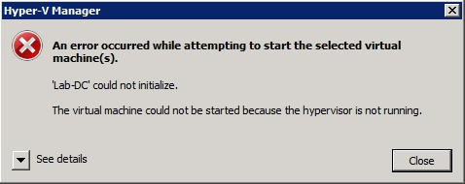
What is the error ?
  - This error occurs as the result of an incorrect BIOS setting. In order for the hypervisor to run, hardware virtualization and data execution prevention must both be enabled within the system’s BIOS.
  - Low Memory.
  - Error in software.
  - Vm is corrputed
- Elina got error when she power-on her vm :
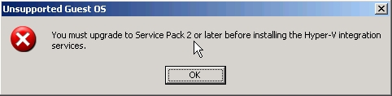
What can a cause of error?
  - Vm is of Gen-1
  - Unsupported Guest OS.
  - Hyper-V has lower version
  - Hyper-v is corrupted.
- Which is not a Type of network switches you can create in Hyper-V ?
  - Nat
  - External
  - Internal
  - Host-host

- The vm’s created in the hyper-v are shown in fig:
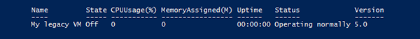
I am not able to create a new vm with following mentioned command . What can be reason of it ?
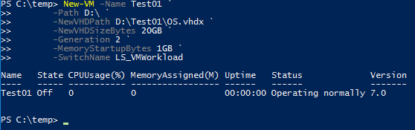
  - No disk space.
  - Hyper-V is not running
  - VMM service is stopped.
  - Inappropriate Hyper-V version.

- Production Checkpoints takes the snapshot backup of :
  - Shadow copy, System freezes.
  - Shadow copy , virtual machine memory
  - Cluster and replica nodes.
  - Shadow copy, Active directory
- Standard Checkpoints takes the snapshot backup of :
- Shadow copy, System freezes.
- virtual machine and virtual machine memory state
- Cluster and replica nodes.
- Active directory
- Using command “Set-VM -Name <vmname> -CheckpointType Production “ fails to create production checkpoint then what will be the result output :
  - standard checkpoint gets created.
  - Fails with error.
  - Process tries continuously until production checkpoint gets created .
  - None of above.

